structral identification of strength degrading hysteresis uSing Nondimensionalized bouc-wen model

Sung-Yong KIM[1] and Cheol-Ho LEE[2],

SUMMARY

This study proposes nondimensionalized Bouc-Wen model, which describes hysteretic behavior with yield displacement, and the nondimensional hysteresis displacement is bounded between -1 and 1. In the proposed model, the dissipated energy is almost equivalent to the displacement per cycle and can be interpreted as the dissipation per an equivalent number of cycles. This interpretation enables us to assign a physical meaning to the degradation per cycle. The applicability of the proposed model was experimentally validated based on an unscented Kalman filter-based parameter identification technique. The identification results show that the nondimensionalized Bouc-Wen model can eliminate the over-fitting problem by converting one hysteresis variable into a variable that can be physically specified as the yield displacement. The convergence rate in estimating the strength and stiffness reduction coefficients was increased as a result of the proposed nondimensionalization.

**Keywords**: Bouc-Wen model; System identification; Unscented Kalman filter; Hysteretic system; Seismic damage; Nonlinear response.

## INTRODUCTION

In recent years, the rapid advancement of measurement and computing technology has allowed civil engineers to implement real-time monitoring techniques for the structural damage evaluation. In particular, it is crucial to quantify the structural damage in seismic engineering not only because the quantified damage is directly related to the safety of the structure, but also to evaluate the cost of repair and reinforcement of the structure. However, it is a challenging problem to quantify seismic damage because it is difficult to describe complex hysteretic behavior. Various phenomenological models of hysteresis have been proposed to describe hysteretic behaviors, and one of the most widely accepted models is a differential model originally introduced in Bouc (1967) and extended in Wen (1976). Due to its versatility, the Bouc--Wen model has been extended to create several variations to simulate strength degradation, stiffness degradation (Kottari, 2014), pinching effects (Baber, 1981; Baber, 1985; Foliente, 1995), and asymmetric behavior (Zhu, 2012; Wang, 2012; Kim and Lee, 2019).

Unfortunately, parameter estimation for the Bouc-Wen model in real time is a complex task because the model is highly nonlinear. In applying the Kalman filter (KF) and its extensions to real problems difficulties in setting the initial states, parameters, and covariances must be resolved. Many previous studies were based on simulations, which allowed reasonable setting for initial states and covariances, but these methods are time-consuming and still not accurate enough to determine the initial parameter values for subsequent estimation. The initial setting problem is particularly cumbersome in the Bouc-Wen parameter estimation because the model involves functionally redundant parameters that do not have a clear physical meaning. To eliminate the redundancy in the Bouc-Wen model, various extensions of the classical Bouc-Wen model have been proposed that are essentially derived from the so-called nondimensionalization technique (Ma et al., 2004; Charalampakis and Koumoiusis, 2008; Sireteanu et al., 2010; Charalampkis and Koumousis, 2008).

The present work proposes an extension of the classical Bouc-Wen model with the nondimensionalization technique that can facilitate real-time parameter estimation through the KF-based monitoring system. A careful review of the existing Bouc--Wen model techniques was conducted, followed by a discussion of the meaning of the proposed model. Second, the applicability of the proposed model was verified through experimental data, based on a UKF-based parameter identification technique.

## Bouc-wen hysteretic model

In the Bouc-Wen model, an auxiliary variable was introduced to simulate the hysteretic behavior. In the Bouc--Wen model, the input--output relationship can be described as a parallel configuration of the linear elastic spring and the hysteretic spring as follows:

|  |  |  |
| --- | --- | --- |
|  |  | (1) |

where *X* and *F*\* are the input and output, respectively; *Z\** is an auxiliary variable that describes the hysteretic behavior; *E* and *L* are constant factors characterizing the input-output and auxiliary variable-output relationships, respectively; and the asterisk designates the variables to be normalized in this section. In the Bouc-Wen model, the hysteretic variable *Z\** is expressed by a first-order nonlinear differential equation whose increment is characterized by the following equation:

|  |  |  |
| --- | --- | --- |
|  |  | (2) |

where *A* is the scale factor between the input and the auxiliary variable; *β\**, *γ*\*, and *n* control the hysteresis shape; sgn(·) is a signum function; and *η\** and *ν*\* describe the strength and stiffness degradation, respectively. One of the degradation models assumes that parameters *η\** and *ν*\* depend linearly on the dissipative energy *ε*\* as the system evolves:

|  |  |  |
| --- | --- | --- |
|  |  | (3) |

|  |  |  |
| --- | --- | --- |
|  |  | (4) |

where two unspecified degradation parameters, *δη*\* and *δν*\*, are introduced. The dissipated quantity can be obtained by integrating the following incremental equation:

|  |  |  |
| --- | --- | --- |
|  | . | (5) |

Assume that the initial slope is independent of the hysteresis, such that its value can be estimated with sufficient accuracy in the experiment. The initial slope tangent to the original input--output relationship is as follows:

|  |  |  |
| --- | --- | --- |
|  | . | (6) |

By introducing normalized variables *Z*=*Z*\*/*A*, *F*=*F*\*/*K*, and α=*E*/*K*, we have the following equations:

|  |  |  |
| --- | --- | --- |
|  |  | (7) |

|  |  |  |
| --- | --- | --- |
|  |  | (8) |

## Nondimensionalization of Bouc-wen model

To nondimensionalize further, the supremum of the hysteretic variable is defined, where strength and stiffness do not decrease; parameters *ν* and *η* are set to unity and solved for variable *z* by setting *dZ*/*dX*=0 to obtain the following:

|  |  |  |
| --- | --- | --- |
|  |  | (9) |

The nondimensional displacements *x*=*X*/*Zu* and *z*=*Z*/*Z*u and force *f*=*F*/*Z*u can be introduced, by which Eq. (7) can be written as follows:

|  |  |  |
| --- | --- | --- |
|  |  | (10) |

Similarly, Eq. (8) can be rewritten as follows:

|  |  |  |
| --- | --- | --- |
|  |  | (11) |

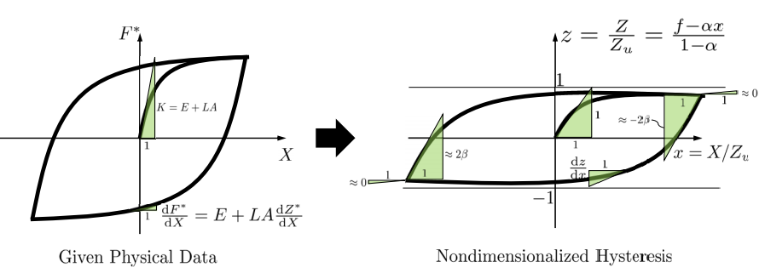

Figure 1 Nondimensionalization of given physical data

Figure 1 depicts the procedure for the extraction of nondimensional hysteresis from given physical data and also shows the characteristics of the proposed nondimensional model in greater detail. It can be seen that the proposed model is normalized to the specified or estimated *Zu*, which is the asymptotic value of hysteresis, so that the nondimensional hysteresis displacement is bounded between -1 and 1. The advantage of capturing the characteristics of the hysteresis model through such a single variable is that it can be more fruitful than the existing model in estimating the hysteresis data.

## application to beam-column connection

The test results conducted by the authors (Kim and Lee, 2017) were used to assess the efficiency of the proposed nondimensional Bouc-Wen model. Two datasets, designated as PN500 and PN500C, were selected, which are the benchmark specimens for the bare steel and composite connections, respectively. An overall view of the test setup is depicted in Figure 2. The column had a length of 3.5 m, and both ends of the column were joined at the top and bottom to the hinges with pins. The distance between the column centerline and the actuator loading point was also 3.5 m. To avoid lateral sliding of the specimens, lateral bracings were provided at a distance of 2.5 m from the column centerline. The input and output were the incremental tip displacements of the actuator and actuator force, respectively. Detailed descriptions of the experimental program can be found in Kim and Lee (2017).

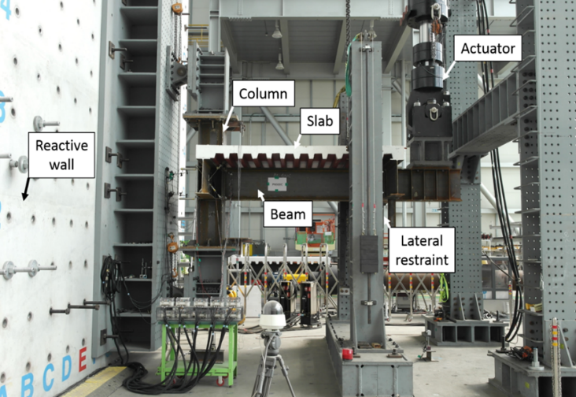 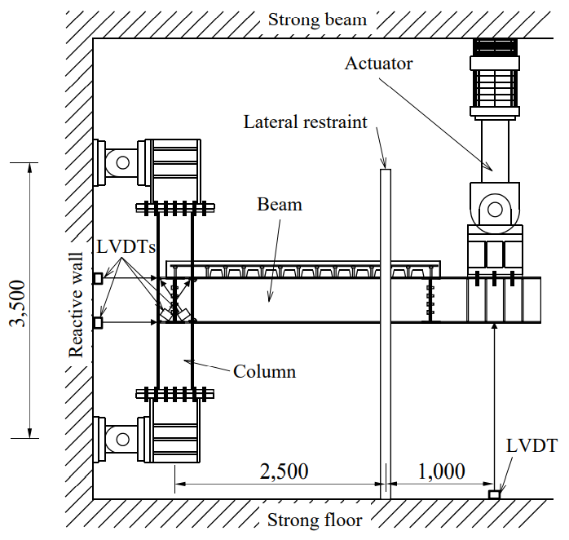

(a) Overall view of test setup (b) Major dimensions

**Figure 2 Test setup (Kim and Lee, 2017)**

The datasets used in this study are depicted in Figure 3. From the perspective of this study, the actuator force and tip displacement are labeled *F\** and *X*, respectively, and the force and displacement are normalized to the yield strength and displacement, respectively. This study assumed that no material tests were conducted, and only nominal yield characteristics were assumed to be available, which is natural for general cases. First, the force--displacement relationship was transformed to the moment--rotation relationship, which is also conventional in seismic engineering. Then, the nominal yield moment and rotation were calculated from the material mechanics.

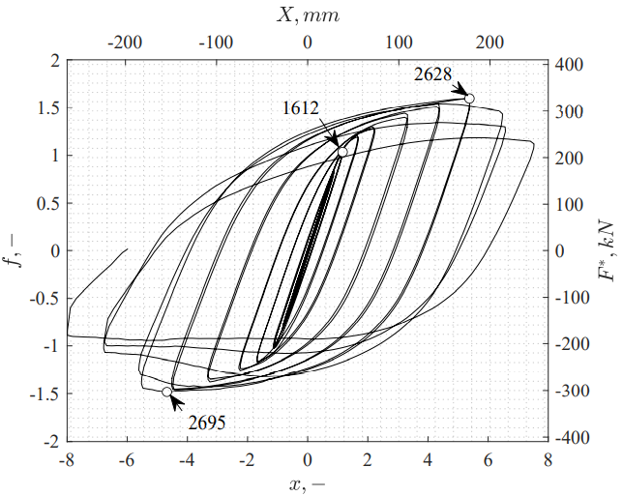 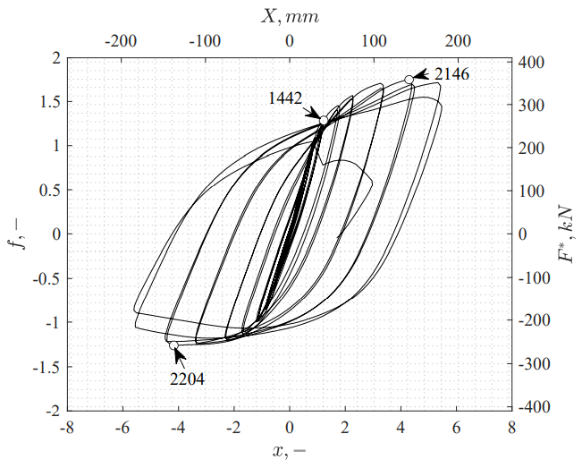

(a) PN500 (b) PN500C

**Figure 3 Test specimens PN500 and PN500C (Kim and Lee, 2017)**

The Unscented Kalman filter (UKF) is a suitable tool for the estimation of the state and model parameters for nonlinear systems because it can handle any nonlinearity in the system without requiring the calculation of Jacobians (Wan and van Der Merwe, 2000; Julier and Uhlmann, 2004). In the UKF, the probability distribution is approximated by a set of deterministic points that capture the mean and covariance of the distribution. These points, called sigma points, are then processed through the nonlinear transition function of the system, producing a set of propagated sigma points. By choosing appropriate weights, the weighted average and the weighted outer product of the transformed points provide an estimate of the mean and covariance of the states.

In order to improve the performance of the UKF filter, a suitable selection of the initial condition is required. First, the initial value and the covariance of the hardening ratio are set to 0.1 and 0.12, which is within the acceptable range of use in steel structure design. The value of *Zu* in the nondimensionalized model, however, is set to unity, which means that the actual yield of the test specimen is assumed to be identical to the nominal yield force. The initial value of *β* is set to 0.6. The value of *γ* in the conventional model is set to 0.4, which is calculated from the initial estimates of the other parameters using Eq. (9). The covariance of *β* and *γ* is set as 0.12, which is arbitrary because it is not appropriate to interpret the meaning of the parameter, as has been discussed. To obtain initial estimates of parameter *Zu*, the maximum likelihood estimation method is presented. Through 1000 simulations with the results of estimating the mean and standard deviation through the maximum likelihood estimation, a covariance value of 0.162 for yield displacement *Zu* was obtained by fitting the calculated based on Eq. (9).

Figure 4 presents the hysteresis curves of experimental data and simulated results obtained by the UKF for the conventional and nondimensionalized Bouc-Wen models. It can be observed from the figures that the UKF is efficient for both PN500 and PN500C specimens to estimate the parameters of the Bouc--Wen hysteresis model. Figure 5 presents the results of the estimated parameters for Test #1, Test #2 and Test #3. It can be observed from the figures that the UKF is efficient for both PN500 and PN500C specimens to estimate the parameters of the Bouc-Wen hysteresis model. Close examination of Test #2 reveals that the estimated values of parameters differ between the conventional and proposed model. Comparing the histories of parameter *δη*, it can be observed that the estimated values obtained from the conventional model are different from those of Test #1 and Test #2, which means that the conventional Bouc-Wen model is sensitive to the initial value setting. Such an over-estimation has been highlighted in several previous studies; the Bouc-Wen model comprises hysteretic parameters that are empirical such that a given set of loop parameters uniquely determines the system response, but a given response may not determine the parameters unambiguously. Such redundancy can occur particularly in the process of estimating parameters related to the shape of the hysteresis. This is because the parameters of the hysteresis model do not have a clear physical meaning. The proposed nondimensionalized model is different from the existing model in this respect. By converting one hysteresis variable *γ* into a variable that can be physically specified as the yield displacement, the parameters of the hysteresis model can be estimated with higher accuracy. This redundancy problem is directly related to the convergence of the strength/stiffness reduction coefficients. As demonstrated through the comparison between Test #2 and Test #3, the strength reduction coefficient is very sensitive to the selection of initial values. This is because the existing model finds the most suitable variable through over-estimation using two hysteresis variables and finds a variable that has a relative size corresponding thereto.

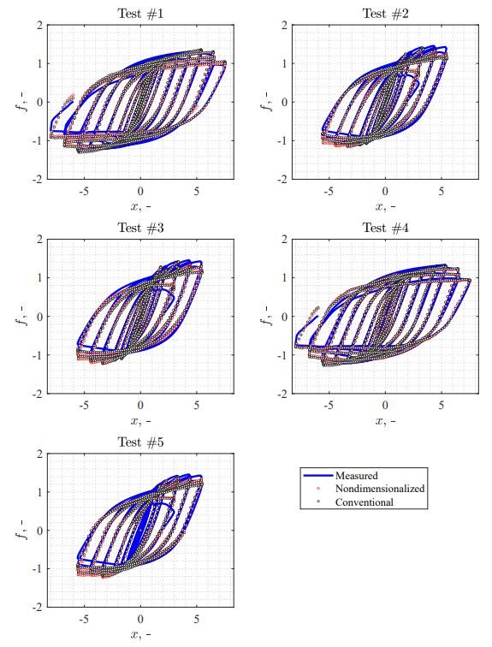

**Figure 4 Comparison of experimental and simulated hystereses**

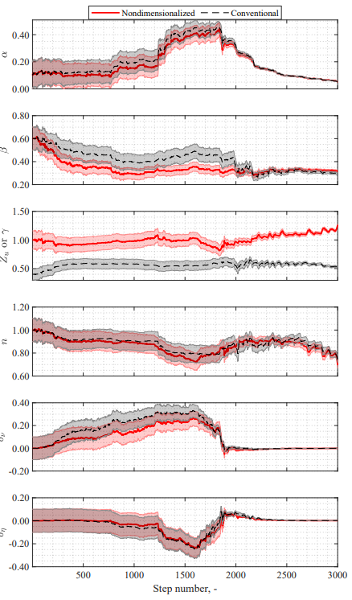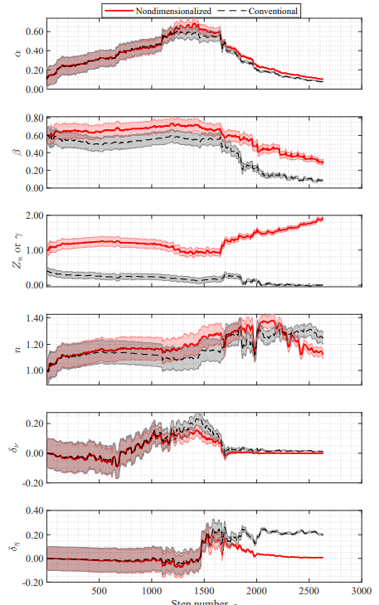 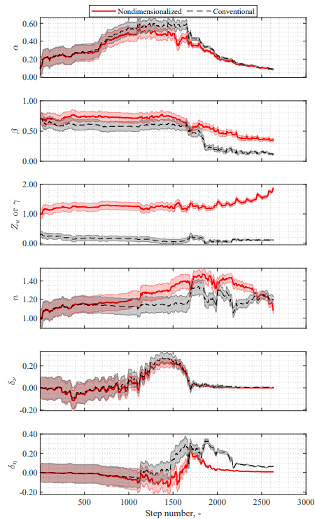

(a) Test #1 (b) Test #2 (c) Test #3

**Figure 5 Estimated parameters for Test #1, #2 and #3**

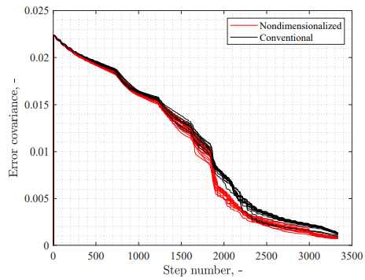 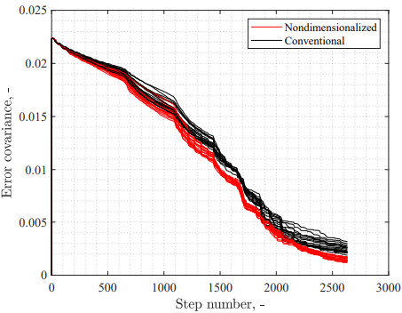

(a) PN500 (b) PN500C

**Figure 6 Comparison of error covariance for hysteresis parameters**

To check the convergence of the simulation results, a comparison of the covariance of errors from the variable estimation were conducted. Figure 6 compares the history of the Euclidean metrics of the error covariance matrix for 30 times of experiments. From Figure 6, it can be seen that the proposed model is superior to the conventional model in terms of the convergence of parameter estimation. First of all, in the case of specimen PN500, both models show stable convergence. However, after the 1600th step when yielding begins, the proposed model shows better convergence. The trend of error covariance after the yielding is similar for both models, but it is clearly shown that the existing model cannot catch up with the superior convergence performance after the yielding. This difference is more evident in specimen PN500C, in that the difference in the convergence performance starts to appear from the 500th step when yielding has not yet started. This is because PN500C has different initial stiffness in the positive/negative moment due to the presence of the concrete slab, and the existing model does not adequately account for this difference in initial stiffness. Overall, the proposed model consistently exhibits better convergence performance beyond the performance of the existing model. The best performance of the conventional model is comparable to the average performance of the proposed model (PN500), or even corresponds to the inferior performance level of the proposed model (PN500C).

## summary and conclusions

In this study, the Bouc-Wen model parameters describing structural degradation that have dimension but no physical meaning were nondimensionalized to eliminate redundancy in the model. The proposed nondimensionalized model describes the hysteretic behavior with the yield displacement, which is the asymptotic value of hysteresis, such that the nondimensional hysteresis displacement is bounded between -1 and 1. In the proposed model, the dissipated energy is almost equivalent to the displacement per cycle and can be interpreted as the dissipation per an equivalent number of cycles. Such an interpretation allows a physical meaning to be assigned to the degradation per cycle. The applicability of the proposed model was experimentally validated based on a UKF-based parameter identification technique. It was shown that the nondimensionalized Bouc-Wen model can circumvent the over-fitting problem by converting one hysteresis variable into a variable that can be physically specified as the yield displacement. The convergence rate in estimating the strength and stiffness reduction coefficients was also enhanced as a result of the proposed nondimensionalization.

REFERENCES

Bouc, R. (1967), “Forced vibrations of mechanical systems with hysteresis”, *Proc. of the Fourth Conference on Nonlinear Oscillations*, Prague.

Wen, Y. K. (1976), “Method for random vibration of hysteresis systems”, *Journal of the Engineering Mechanics Division*, 102(2): 249-263.

Kottari, A. K., Charalampakis, A. E., Koumousis, V. K. (2014), “A consistent degrading Bouc-Wen model”, *Engineering Structures* 60: 235-240.

Baber, T. T., Wen, Y. –K. (1981), “Random vibration of hysteretic degrading systems”, *Journal of the Engineering Mechanics Division* 107 (6): 1069-1087.

Baber, T. T., Noori, M. N. (1985), “Random vibration of degrading, pinching systems”, *Journal of Engineering Mechanics* 111 (8): 1010-1026.

S.-Y. Kim, C.-H. Lee (2017), “Seismic retrofit of welded steel moment connections with highly composite floor slabs”, *Journal of Constructional Steel Research*, 139: 62–68

S.-Y. Kim, C.-h. Lee (2019), “Description of asymmetric hysteretic behavior based on the Bouc-Wen model and piecewise linear strength-degradation functions”, *Engineering Structures*, 181:181–191.

G. C. Foliente (1995), “Hysteresis modeling of wood joints and structural systems”, *Journal of Structural Engineering*, 121(6): 1013–1022.

W. Zhu, D.-H. Wang (2012), “Non-symmetrical Bouc–Wen model for piezoelectric ceramic actuators”, *Sensors and Actuators A: Physical,* 181:51–60.

G. Wang, G. Chen, F. Bai (2015), “Modeling and identification of asymmetric Bouc–Wen hysteresis for piezoelectric actuator via a novel differential evolution algorithm”, *Sensors and Actuators A: Physical,* 235:105–118.

F. Ma, H. Zhang, A. Bockstedte, G. C. Foliente, P. Paevere (2004), “Parameter analysis of the differential model of hysteresis”, *Journal of Applied Mechanics*, 71(3): 342-349.

A. Charalampakis, V. Koumousis (2008), “On the response and dissipated energy of Bouc–Wen hysteretic model”, *Journal of Sound and Vibration*, 309(3-5):887–895.

T. Sireteanu, M. Giuclea, A. Mitu (2010), “Identification of an extended Bouc–Wen model with application to seismic protection through hysteretic devices”, *Computational Mechanics*, 45(5): 431–441.

A. Charalampakis, V. Koumousis (2008), Identification of Bouc–Wen hysteretic systems by a hybrid evolutionary algorithm, *Journal of Sound and Vibration*, 314(3-5): 571–585.

E. A. Wan, R. Van Der Merwe (2000), “The Unscented Kalman filter for nonlinear estimation”, *Proceedings of the IEEE 2000 Adaptive Systems for Signal Processing, Communications, and Control Symposium (Cat. No.00EX373)*: 153–158.

S. J. Julier, J. K. Uhlmann (2004), “Unscented filtering and nonlinear estimation”, *Proceedings of the IEEE,* 92(3):401–422

1. Assistant professor, Changwon National University, Korea, e-mail: [sungyong.kim@changwon.ac.kr](mailto:sungyong.kim@changwon.ac.kr)
2. Professor, Seoul National University, Korea, e-mail: [ceholee@snu.ac.kr](mailto:ceholee@snu.ac.kr)